**Practical No. 2**

**Negative image**

% Name: Sonal Girish Kulkarni

% Roll No: 31176

% reading the RGB file into the Matlab environment

skI = imread("cameraman.tif");

subplot(1, 2, 1),

% displaying the RGB image

imshow(skI);

title("Original image"); imhist(skI) 10.

% levels of the 8-bit image

L = 2 ^ 8;

% finding the negative

neg = (L - 1) - skI; 16. subplot(1, 2, 2),

% displaying the negative image

imshow(neg);

title("Negative Image")

imhist(neg)

**Output:**

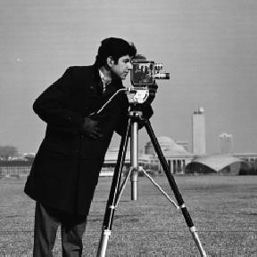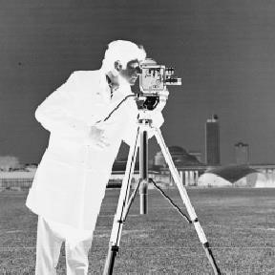

Histogram of original image Histogram Negative image

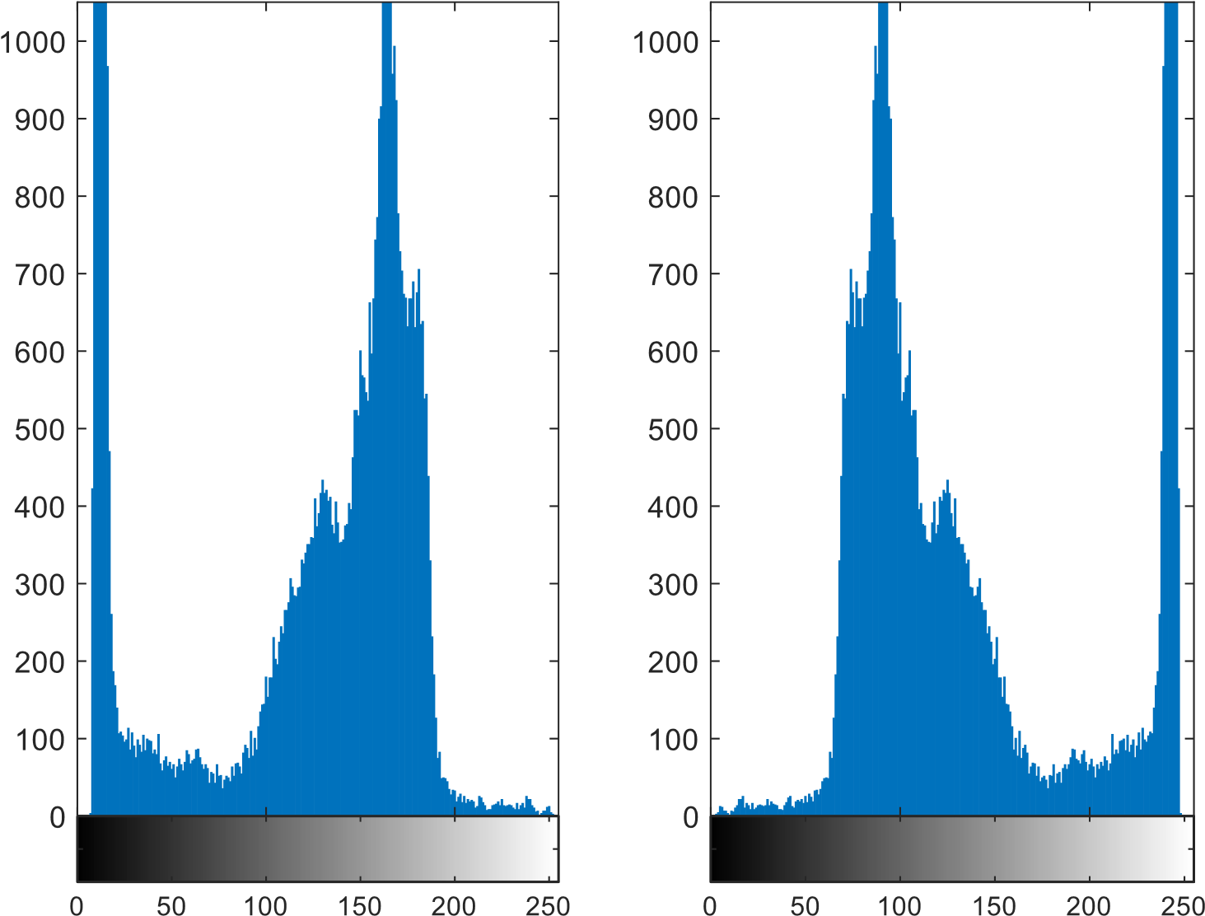

1. **Flip an image(Mirror Image)**

img = imread('cameraman.tif'); %Name :Sonal Girish Kulkarni img2 = flip(img,2);

subplot(1,2,1) % Roll No: 31176 imshow(img) title('Original Image') subplot(1,2,2) imshow(img2) title('Flipped Image')

imhist(img2) **Output:**

# Original imageFlipped image

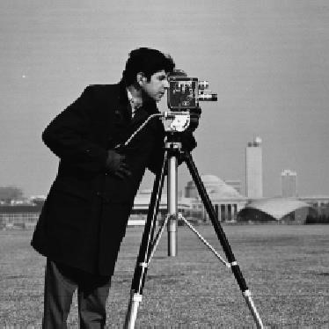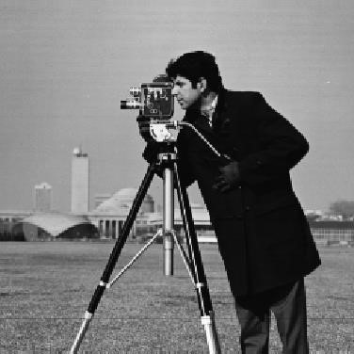

**Vertical flip:** img = imread('cameraman.tif'); %Name :Sonal Girish Kulkarniimg2 = flip(img);

subplot(1,2,1) % Roll No: 31176imshow(img)

title('Original Image') subplot(1,2,2) imshow(img2)

title('Flipped Image')

**Output:**

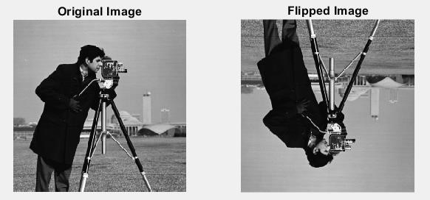

Histogram of original image: Histogram of Flipped image

